Seth Huntley

CIT 360

2019.03.26

CIT 360 Professional Behavior

1. 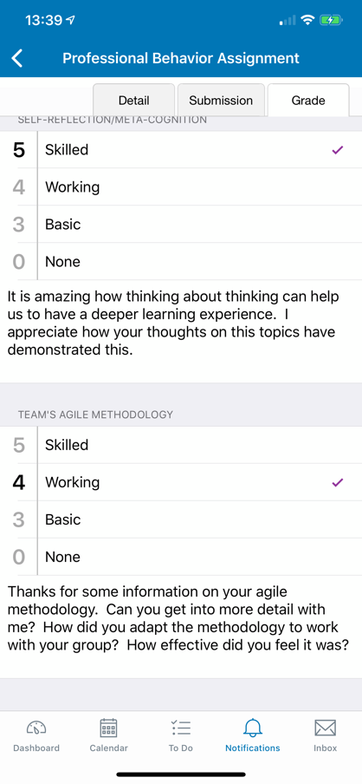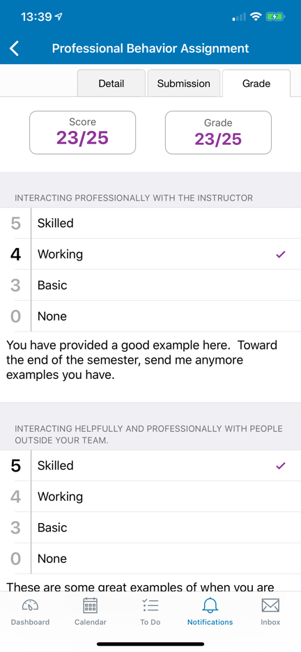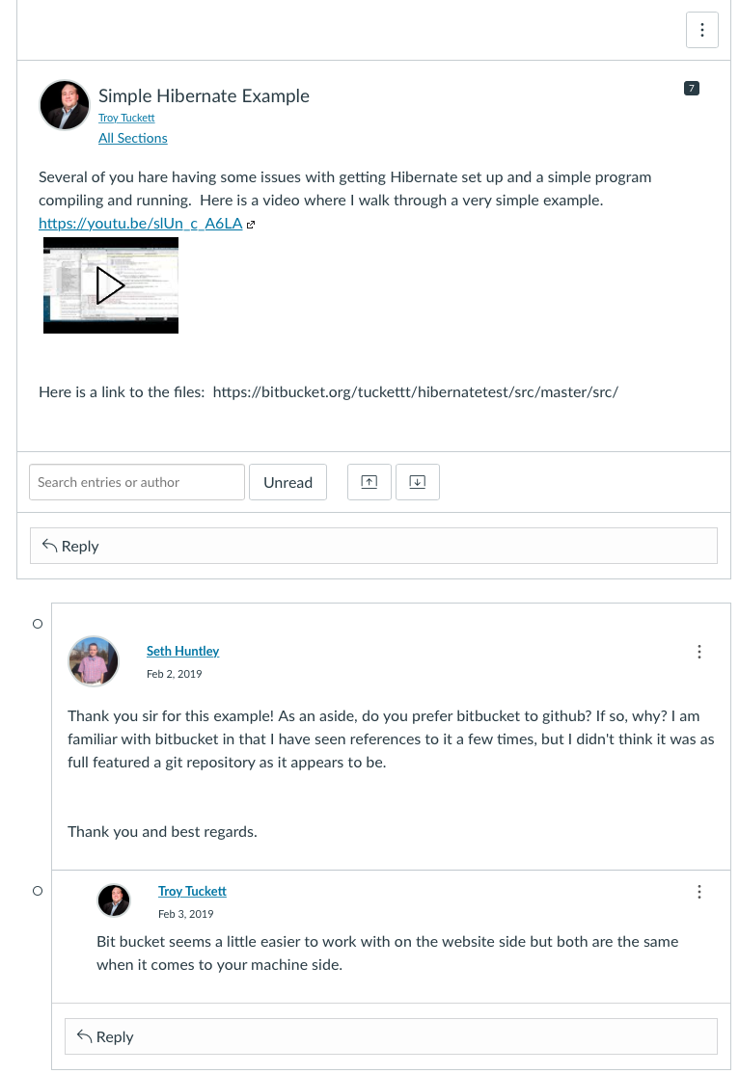**Interacting professionally with the instructor**  
   I believe that my interactions with the professor have been professional and above board, limited though they may have been. I added the feedback from the earlier iterations of this assignment as evidence of professional interaction. I took the feedback and modified my assignment accordingly.
2. **2. Interacting helpfully and professionally with people outside your team.**  
   I made it a point to try and participate in the developer forums to try and help anyone that I could with my own limited experience and skillset. I feel that I may have helped people.

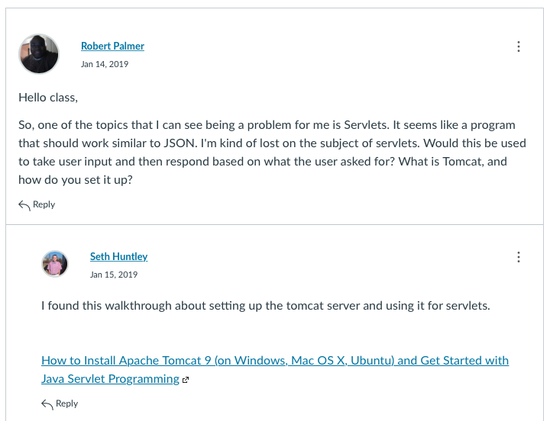

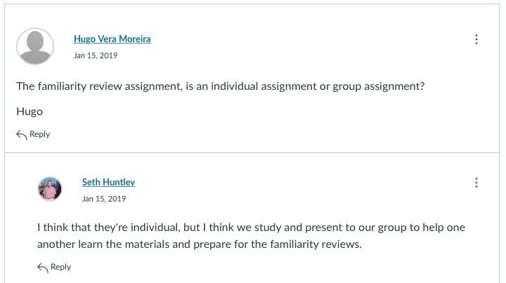

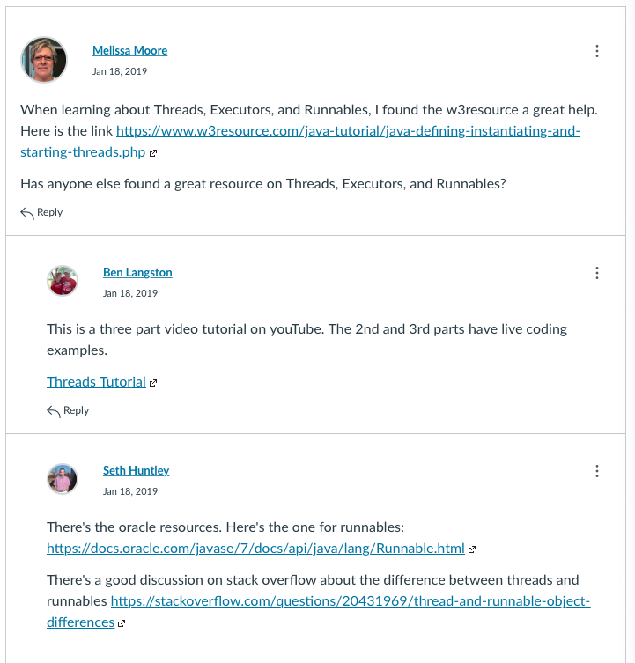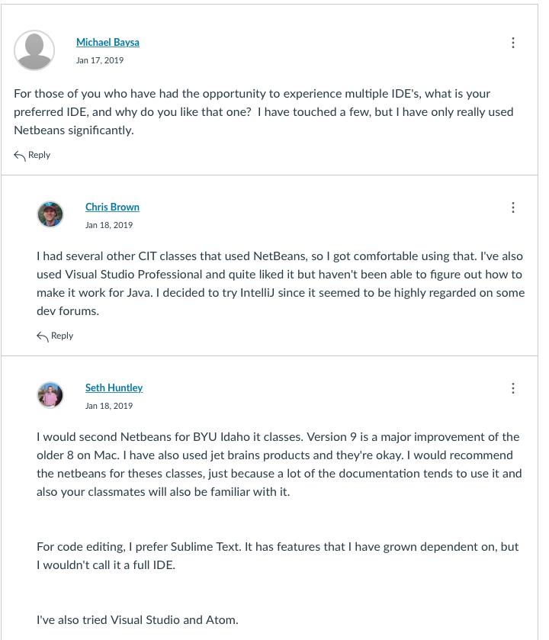

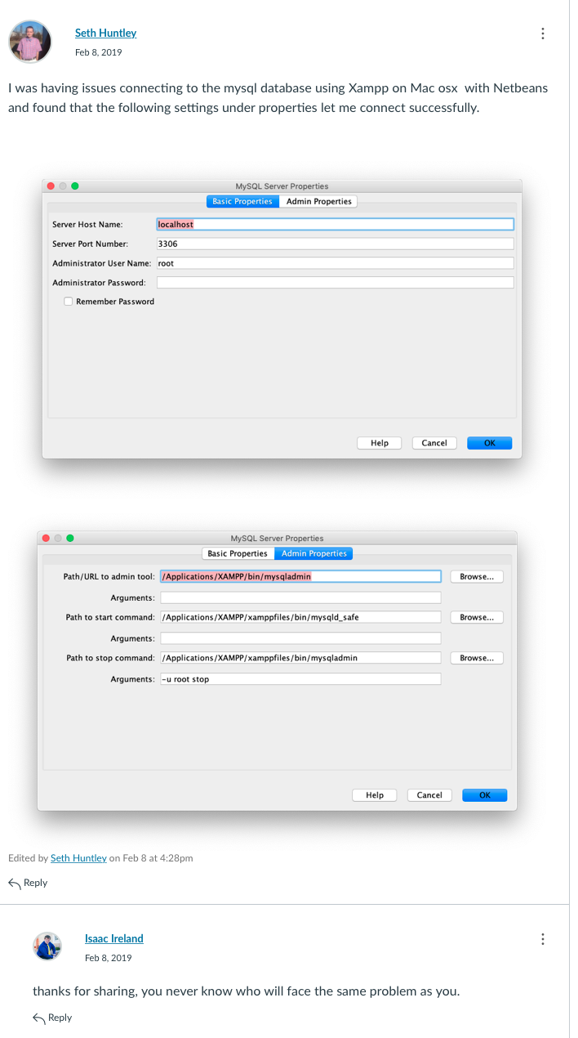

1. **Interacting professionally within your team**  
   I met with our team weekly and did my best to work as a team. I was assigned a great team and learned a lot from working with them. We always had cordial discussions and discussed not only the needs of this class, but also other classes that people were taking and issues of personal life such as the risks involved with purchasing an electric car that one member was considering and how another member’s job interviews were going. We were all in constant contact via a Slack channel that was established for the group. This made communication much easier than relying exclusively on email or the BYUI communications portal.

**A link to my teaching on junit tests** [**https://www.youtube.com/watch?v=OuTDFuIreQ8&t=9m45s**](https://www.youtube.com/watch?v=OuTDFuIreQ8&t=9m45s)

**A link to my presentation on use case diagrams http://www.youtube.com/watch?v=_eoEvUkvj9I&t=0m10s**

1. **Self-reflection/Meta-cognition**This is the second time that I have tried to take this course. I was overwhelmed the first time that I tried it and the course’s format of familiarity reviews still doesn’t sit squarely in my wheelhouse, but I have tried to meet all of the course requirements this time around and do better with the familiarity reviews and all other course activities.  
   I would be lying to say that I haven’t struggled with this course a great deal. The format still seems alien to me, but I will improvise, adapt, and overcome to the best of my abilities.

**I think that trying to disassemble my learning style and figure out what works for me helped me to make it much farther in this class this semester than the last time I tried it. I realized that I am much better at looking to examples of code and building on them to meet my purposes as a learner. I have problems starting something, but am good at continuing and finishing,**

1. **Team’s agile methodology**Our team’s agile methodology was the agile method. We worked to collaborate on the various teaching assignments and added helpful feedback to each other in the individual projects. We were self-organized in working on our individual familiarity reviews and teaching assignments, while also providing help to each other as needed or when we saw opportunities to aid each other in either the familiarity reviews or teaching assignments. After meeting with my group last night and discussing the semester and how we used the agile methodology in our teaching and learning, and we came to the consensus that we used the Agile methodology by breaking up the tasks of weekly teaching in equal parts and scheduling each teaching opportunity. We met weekly and created and used a Slack channel to collaborate as needed throughout the semester. The Slack channel was helpful and allow communication in situations where a video chat was impossible or very difficult, e.g. while at work or similar situations. It was especially useful when someone needed an answer quickly. This crowdsourcing of answers and assistance was very helpful. An additional advantage of the Slack channel was the ability to review earlier conversations and find links and resources posted in a simple and timely manner.